Assignment 3 – Relationship between below two images in regards to Mean, Median & Mode.

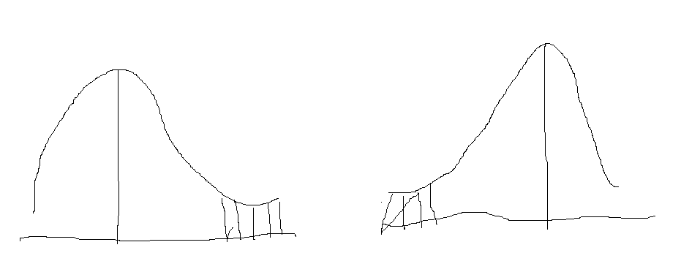

Ans – It is connected with each other as a ‘log normal distribution’.